**Project Design Phase-II**

|  |  |
| --- | --- |
| **Date** | **24 June 2025** |
| **Team ID** | **LTVIP2025TMID20425** |
| **Project Name** | **LearnHub: Your Center for Skill Enhancement** |
| **Mentor Name** | **Dr Shaik Salma Begam** |
| **Maximum Marks** | **4 Marks** |

**Data Flow Diagram & User Stories**

## **Data Flow Diagram (DFD)**

A **Data Flow Diagram (DFD)** visually represents how **information flows within LearnHub**. It helps stakeholders understand **how data enters the system, how it's processed, transformed, and stored**, and how it interacts with external entities such as users (students, instructors, and admins).

## **Example: Level 0 for LearnHub**

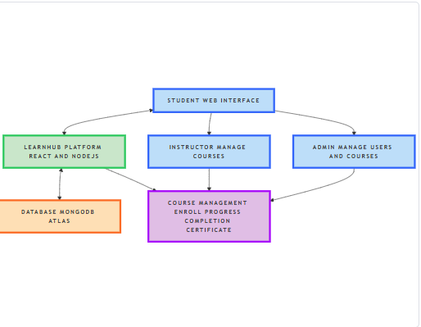

**Description:**

* **Students** register, log in, and browse available courses.
* Upon **enrollment**, course data is fetched and progress is tracked.
* After course completion, the system generates a **certificate**.
* **Instructors** can create, edit, and manage course content.
* **Admins** manage users, courses, and oversee overall platform performance.

**User Stories for LearnHub**

|  |  |  |  |  |  |  |
| --- | --- | --- | --- | --- | --- | --- |
| **User Type** | **Functional Requirement (Epic)** | **User Story Number** | **User Story / Task** | **Acceptance Criteria** | **Priority** | **Release** |
| Student (Web) | Registration | USN-1 | As a student, I can register by entering my name, email, and password. | I can access my dashboard after registration. | High | Sprint-1 |
| Student (Web) | Registration Confirmation | USN-2 | As a student, I receive a confirmation email after registering. | I can confirm my email and activate the account. | High | Sprint-1 |
| Student (Web) | Login | USN-3 | As a student, I can log in using my email and password. | I am redirected to my personalized dashboard. | High | Sprint-1 |
| Student (Web) | Course Browsing & Search | USN-4 | As a student, I can search or browse courses by category. | I see relevant courses with filters. | High | Sprint-1 |
| Student (Web) | Course Enrollment & Access | USN-5 | As a student, I can enroll in a course and access the content. | I can view full content and track progress. | High | Sprint-2 |
| Student (Web) | Course Completion & Certificate | USN-6 | As a student, I can download a certificate after completing a course. | I receive a PDF certificate with my name and course title. | High | Sprint-3 |
| Instructor | Course Management | USN-7 | As an instructor, I can create, update, or delete courses. | Courses are reflected on the student side. | High | Sprint-2 |
| Admin | Admin Dashboard & User Management | USN-8 | As an admin, I can manage users, instructors, and monitor platform usage. | Admin can view, update, or delete user/course data. | High | Sprint-3 |